Hospital Appointment system

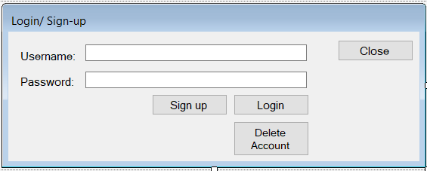
This is the main login page which the patient/ doctor uses to log in.

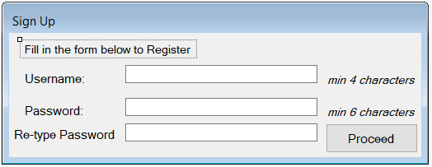
If the person chose to sign up, the sign up credentials are recorded using this form.
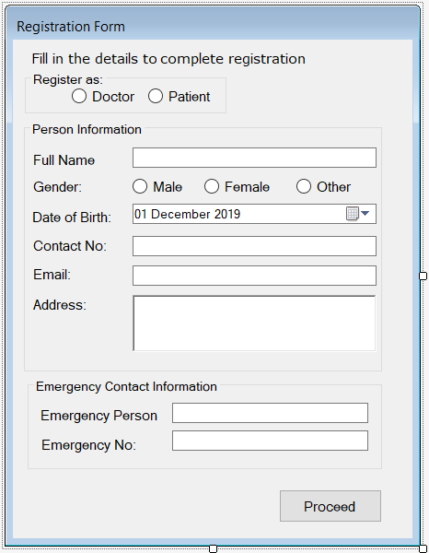
This form then takes all the general information for the person.
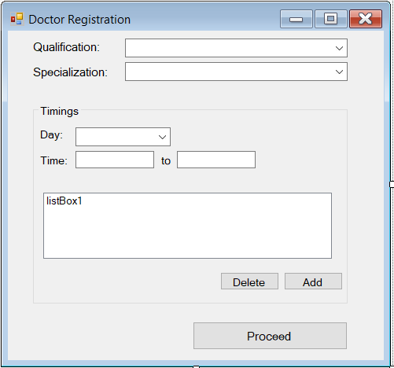
If the person being registered was a doctor, the additional information will be taken using this form.

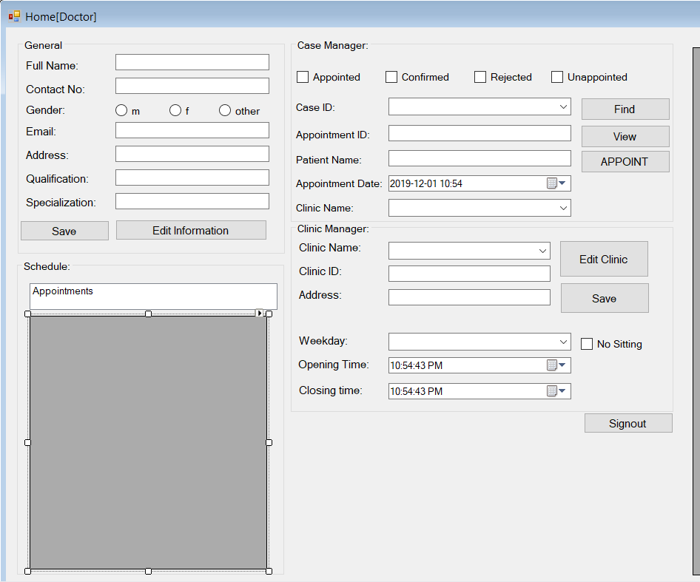
This is the doctors homepage which he can use to see appointment requests and accept, reject their appointment.
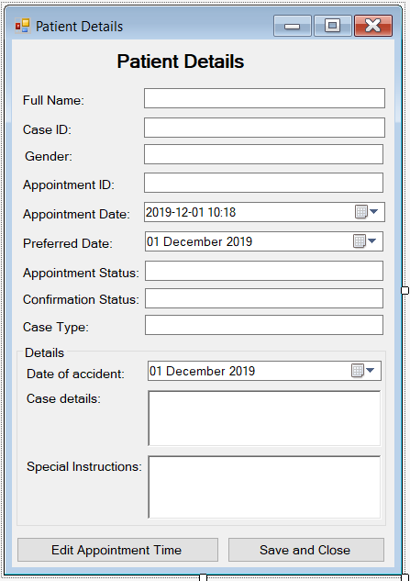
This form displays the information for patients, they can also use this form to edit their appointment time.
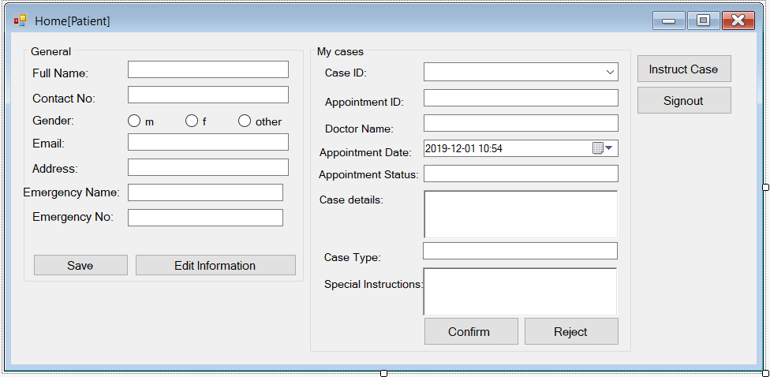
This is the patient’s homepage from where he can go to request an appointment, and also accept/reject appointment after the doctor has scheduled an alternate time.

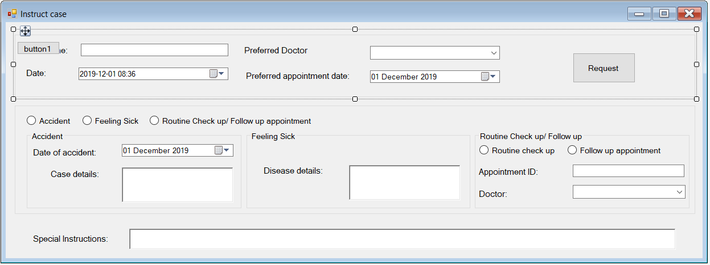
This form is used by the patient to provide details to book an appointment with a doctor.

